Buried pellet test protocol

Buried Pellet: Test used to measure olfactory function.

Materials:
- Tripods
- Cameras with chargers
- Clean/spare cages
- Timer
- Pens
- Extra cards for animal/cage ID
- LabBook
- Setup for recording clasping
- Clean cages with 3cm Bedding + Ruler
- Food Pellets
- Cage dividers (paper)
- Special protocol stickers

Notes on preparation:
- Do not conduct this test simultaneously with GI tract or behaviour as it could influence the results.
- Mice should be at least 8-week-old:
  - We used 8-week-old C57BL/6J background mice of both sexes, it is important that the animals have the same age.
  - In females, estrus can effect olfactory discrimination. Considering this, we initially did statistical analysis in separating genders: wild-type (4 males and 5 females), heterozygote (3 males and 3 females) and conditional knock-out mice (4 males and 5 females). However, we observed no differences between genders, so in our final results, we used both genders in all groups. We recommend evaluating the differences between genders before deciding to use mixed-gender groups or not.
- If possible, test mice during their active phase in the dark cycle. In our case is not possible (dark cycle starts at 21h), so all three tests will be performed during light cycle. Keep in mind that sniffing times may decrease when mice are tested during their sleep cycle.
- Avoid using perfume and strong odorants on the days performing the tests.
- In order to reduce any effect of outside olfactory cues, wear a base pair of gloves at all times throughout each test and then place a clean pair of gloves over the base pair for each mouse and each trial. As a general rule, when in doubt, put on a clean set of gloves. Have a box of gloves readily available since they will be changed frequently. NOTE: We use nitrile gloves for all animal handling.
- Place the mouse in the cage at the diagonal of the spot where the pellet is buried. Check the mouse tag after the test. Show the card with the cage number and mouse ID at the end of each recording.
- Put a "map" at a spot which is visible for the camera so you know where the pellet is hidden during analysis.
- Cleaning test materials and cages between subjects with a disinfectant/sterilizing agent is also an important step in this battery of tests in order to reduce the potential for spreading disease as well as remove undesired olfactory cues.

Notes on setup:
- Chow pellets (Food stimulus): We use ssniff® R/M-H pellets. The composition of this diet can be found here https://www.kuleuven.be/animalia/downloads/suppliers/food/ssniff_rmh.pdf
- For each subject, a clean cage washed and dried by the animal care cage washing facility and clean bedding should be used. Do not re-use cages or bedding.
  - Do not use regular cage lids. The stainless-steel top which holds food and water interferes with observation and should not be included in the setup.
  - Fresh cage bedding to create an 3 cm layer in each cage. Cage lining: we use Animal Bedding Lignocel® BK 8/15 to bury the pellet.
- The presence of a human observer may influence animal behavior. The use of a video camera may help reduce human interference during the test. All videos were recorded in .avi format and viewed using VLC media player.
- Make sure the cards indicating the cage and animal tag are clearly visible on the video. For security, also mention out loud which cage and which mouse is getting recorded.

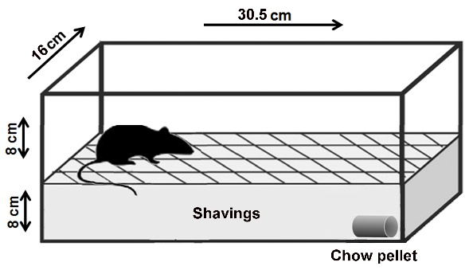

Buried Pellet Test (20h dark cycle fasting)
- Deprive (ontnemen) 8-week-old mice of food for 20 h before the test. Put the mice in a fresh cage to be sure no chow pellets are present. Do not remove the water bottle (ad libitum).
- Place a 'Special protocol' sticker - No Food on the cage lid - So the animal caretakers do not add food.
- On test day, habituate the mice for 30 min prior to testing by placing their cage in the testing room with no water bottle or feeder bin (make sure you remove the metal grid). House them in their home cage with just a filter top lid.
- During room habituation, fill clean mouse cages (1 per mouse) with ~3 cm high with clean bedding making certain the bedding is evenly distributed throughout the cage. Burry the pellet at the bottom in one of corners, make sure the pellet is not visible. Make a "map" with a drawing where the pellet is hidden. This "map" can be placed in the view of the camera during the test.
- Place two fresh cages with 3 cm bedding and a hidden pellet in the frame of the camera and put papers around so the mice will not see each other and cannot jump out of the cage. Place the "map" of the hidden pellet in the frame of the camera during the whole testing round.
- Place the testing mouse in the opposite corner of the test cage (two cages, and so two mice, can be tested during one recording) and start the timer.
- Stop the timer when the mouse uncovers the pellet and begins eating it. Note the time to uncover the buried pellet (time is accounted until mouse touches pellet)
- If the mouse does not find the pellet within 5 min, end the trial and note a score of 300 sec for that mouse.
- Following the trial, return the mouse to a new cage (ad libitum food and water). Do not return the mouse to the home cage if there are still mice that have not been tested!
- Repeat steps 4 to 9 for each mouse.
- Analyse data

Depending on variability within mice repeat trials 1 more time.
Allow for one regular day of ad libitum food and water within trials and repeat (Bury the pellet in a different spot in the cage for each trial).
    - Day 1: Remove Food
    - Day 2: Test -> Back to regular food
    - Day 3: Remove Food
    - Day 4: Test -> Back to regular food

Optional
- Day 5: Remove Food
- Day 6: Test -> Back to regular food

